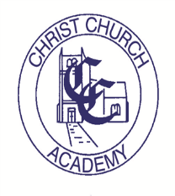

CHRIST CHURCH COMMUNITY HALL & ACADEMY
FOLKESTONE

HIRE CHARGES

ROOM | PER SESSION UP TO 3 HOURS  £ | PER HOUR  £
MAIN HALL | 45.00 | 15.00
MEETING ROOM | 45.00 | 15.00
SWIMMING POOL | 45.00

A laptop trolley with 16 laptops is available to hire at an additional cost of £175 per 3 hour session.

The Community building has wireless internet access, under floor heating, movement sensor lighting, kitchen facilities and toilets including baby changing facilities.

No ball games are allowed in the building and no activity should take place or footwear worn which will puncture the flooring and thus damage the under floor heating system.

Please contact Mrs R Richter, Business Manager on 01303 253645 or email to r.richter@christ-church-folkestone.kent.sch.uk to enquire or make bookings.

These are the standard hire charges. Concessions may be made in certain circumstances by prior arrangement.

