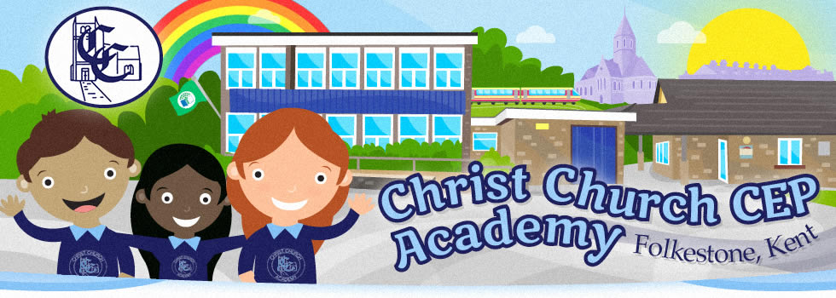

Remote Learning Policy

Striving to be the best version of ourselves every day.

Inspired by God’s love, we humbly strive to be
the best version of ourselves every day, in every way.

We cherish the dignity of each precious person:
thankfulness, friendship, forgiveness and hope
are at the heart of our inclusive community.

Remote Learning Policy
September 2020

Vision Statement:

Inspired by God’s love, we humbly strive to be the best version of ourselves every day, in every way. We cherish the dignity of each precious person. Thankfulness, friendship, forgiveness and hope are at the heart of our inclusive community.

Specific Aims of this Policy:
- To outline our approach for pupils that will not be attending school, as a result of government guidance or the closure of a class bubble
- To outline our expectations for staff that will not be attending school due to self-isolation but that are otherwise fit and healthy and able to continue supporting with the teaching, marking and planning for pupils.
Who is the policy applicable to?
Every child is expected to attend school from September 1st 2020. In line with government guidance, pupils, staff and families should self-isolate if they display any of the following symptoms:
- A continuous, dry cough
- A high temperature above 37.8℃
- A loss of, or change to, their sense of smell or taste
- Have had access to a test and this has returned a positive result for Covid-19
This policy is intended to outline expectations for class bubbles or partial school closure, rather than individual cases. Individual pupils who are isolating due to health issues (based on government advice) and choose not return to school will be supported on a case by case basis, primarily with the use of ‘packs’ and/or Online Learning via Purple Mash which reflects the curriculum content which the pupil can access independently.
Remote Learning for Pupils
We will provide links to appropriate remote learning or work for pupils that are not able to attend school so that no one need fall behind. In the following points, an outline of the provision will be made and some guidance given on the role of pupils, teachers and parents. The governors and senior leadership team at Christ Church CEP Academy are fully aware that these are exceptional times and would like to make it clear that the completion of work is not compulsory and that this document seeks to inform and guide families and not impose expectations. Each family is unique and because of this, should approach home learning in a way which suits their individual needs. We realise that the circumstances that cause our school to close will affect families in a number of ways.
In our planning and expectations, we are aware of the need for flexibility from all sides:
- Parents may be trying to work from home so access to technology as a family may be limited;
- Parents may have two or more children trying to access technology and need to prioritise the needs of young people studying towards GCSE/A Level accreditation;
- Teachers may be trying to manage their home situation and the learning of their own children;
- Systems may not always function as they should.

Teacher Expectations
Teachers will plan lessons that are relevant to the curriculum for that year group and endeavour to supply resources to support tasks for home learners. Work for the week in English, Maths and other subjects will be provided in good time for learners to access from home. If a child is sent home because they are displaying symptoms of COVID, they will be sent home with work which will last for around 3 school days. This work does not need to be returned to school unless the equipment belongs to school or has been discussed in advance. Work will also be set on Purple Mash or Dojo for pupils to use if this is their preferred means of accessing home learning.
In the event of a lockdown or students having to isolate owing to a positive test of COVID, work for the ten-day self-isolation period will be set. This will be set via Class Dojo where teachers will add instructions in the forms of written explanation and videos which will explain the learning and the task. Teachers will be contactable so they can respond to children/parents as and when required. As much as possible, the work set will be so the children can complete it independently without impacting on parents. Work will be set daily, feedback given as appropriate and then reviewed. Occasionally, the children may be invited to come together via Zoom for a class story or an emotional check in as a class. In addition to the daily work set, work will also be available on Purple Marsh for children to complete if they wish to enhance their learning experience and give them the opportunity to demonstrate their understanding in a range of tasks.
Teachers will respond promptly, within reason, to requests for support from families at home. This should be done via Dojo. Staff and parents should communicate via the class dojo. Staff will endeavour to respond within forty-eight hour during the school day unless the whole class/school is closed.
Should a staff member require support with the use of technology, it is their responsibility to seek this support in school and Senior Leaders will ensure that support is given promptly.
Family (pupil/parent/guardian) Role
Where possible, it is beneficial for young people to maintain a regular and familiar routine. Christ Church CEP Academy would recommend that each ‘school day’ maintains structure.
- If a class bubble is isolated, the children will be sent home with their home reading book in addition to their paper pack if required. Work will be set on Class Dojo daily and work will also be set on Purple Mash but this is optional in terms of completion.
- Should anything be unclear in the work that is set, parents can communicate with class teachers via the class dojo. They should make clear which year group and subject the question relates to.
- We would encourage parents to support their children’s work, by viewing the work set together, and then making appropriate plans to complete the work. This can include finding an appropriate place to work and, to the best of their ability, supporting pupils with work encouraging them to work with good levels of concentration.
- Every effort will be made by staff to ensure that work is set promptly on appropriate platforms but school cannot guarantee that the chosen platforms will work on all devices. Should accessing work be an issue, parents should contact school promptly and alternative solutions will be made available (e.g. paper copies of work etc). These will be discussed on case-to-case basis.
Remote teaching for staff who are self-isolating
Teaching staff are required to self-isolate if they show symptoms outlined at the start of this policy or they have been told to shield and/or have received a letter to confirm this. If a member of staff is required to self-isolate, they are expected to:
• Follow normal reporting procedure for planned absence.
• Following contact with school, the Headteacher may set up a referral to Occupational Health to support that individual.
• It is expected that staff get tested. Should a staff member be tested, it is expected, as per national guidance, to share the result of this test with school so that appropriate plans can be made.
• Whilst self-isolating, and if able to do so, non-teaching staff will be given an individual project to work on which is in line with whole school improvement priorities or asked to support with the online learning provision for their year group. These projects will be communicated by the Senior Leadership Team and will be allocated on a case-by-case basis.
• If unwell themselves, teachers will be covered by another staff member for the sharing of activities. Communication and planning during this time will not be undertaken until the teacher is fit to work.

Date of validation…………………… Signed………………………………………………….
Chair of Governors

