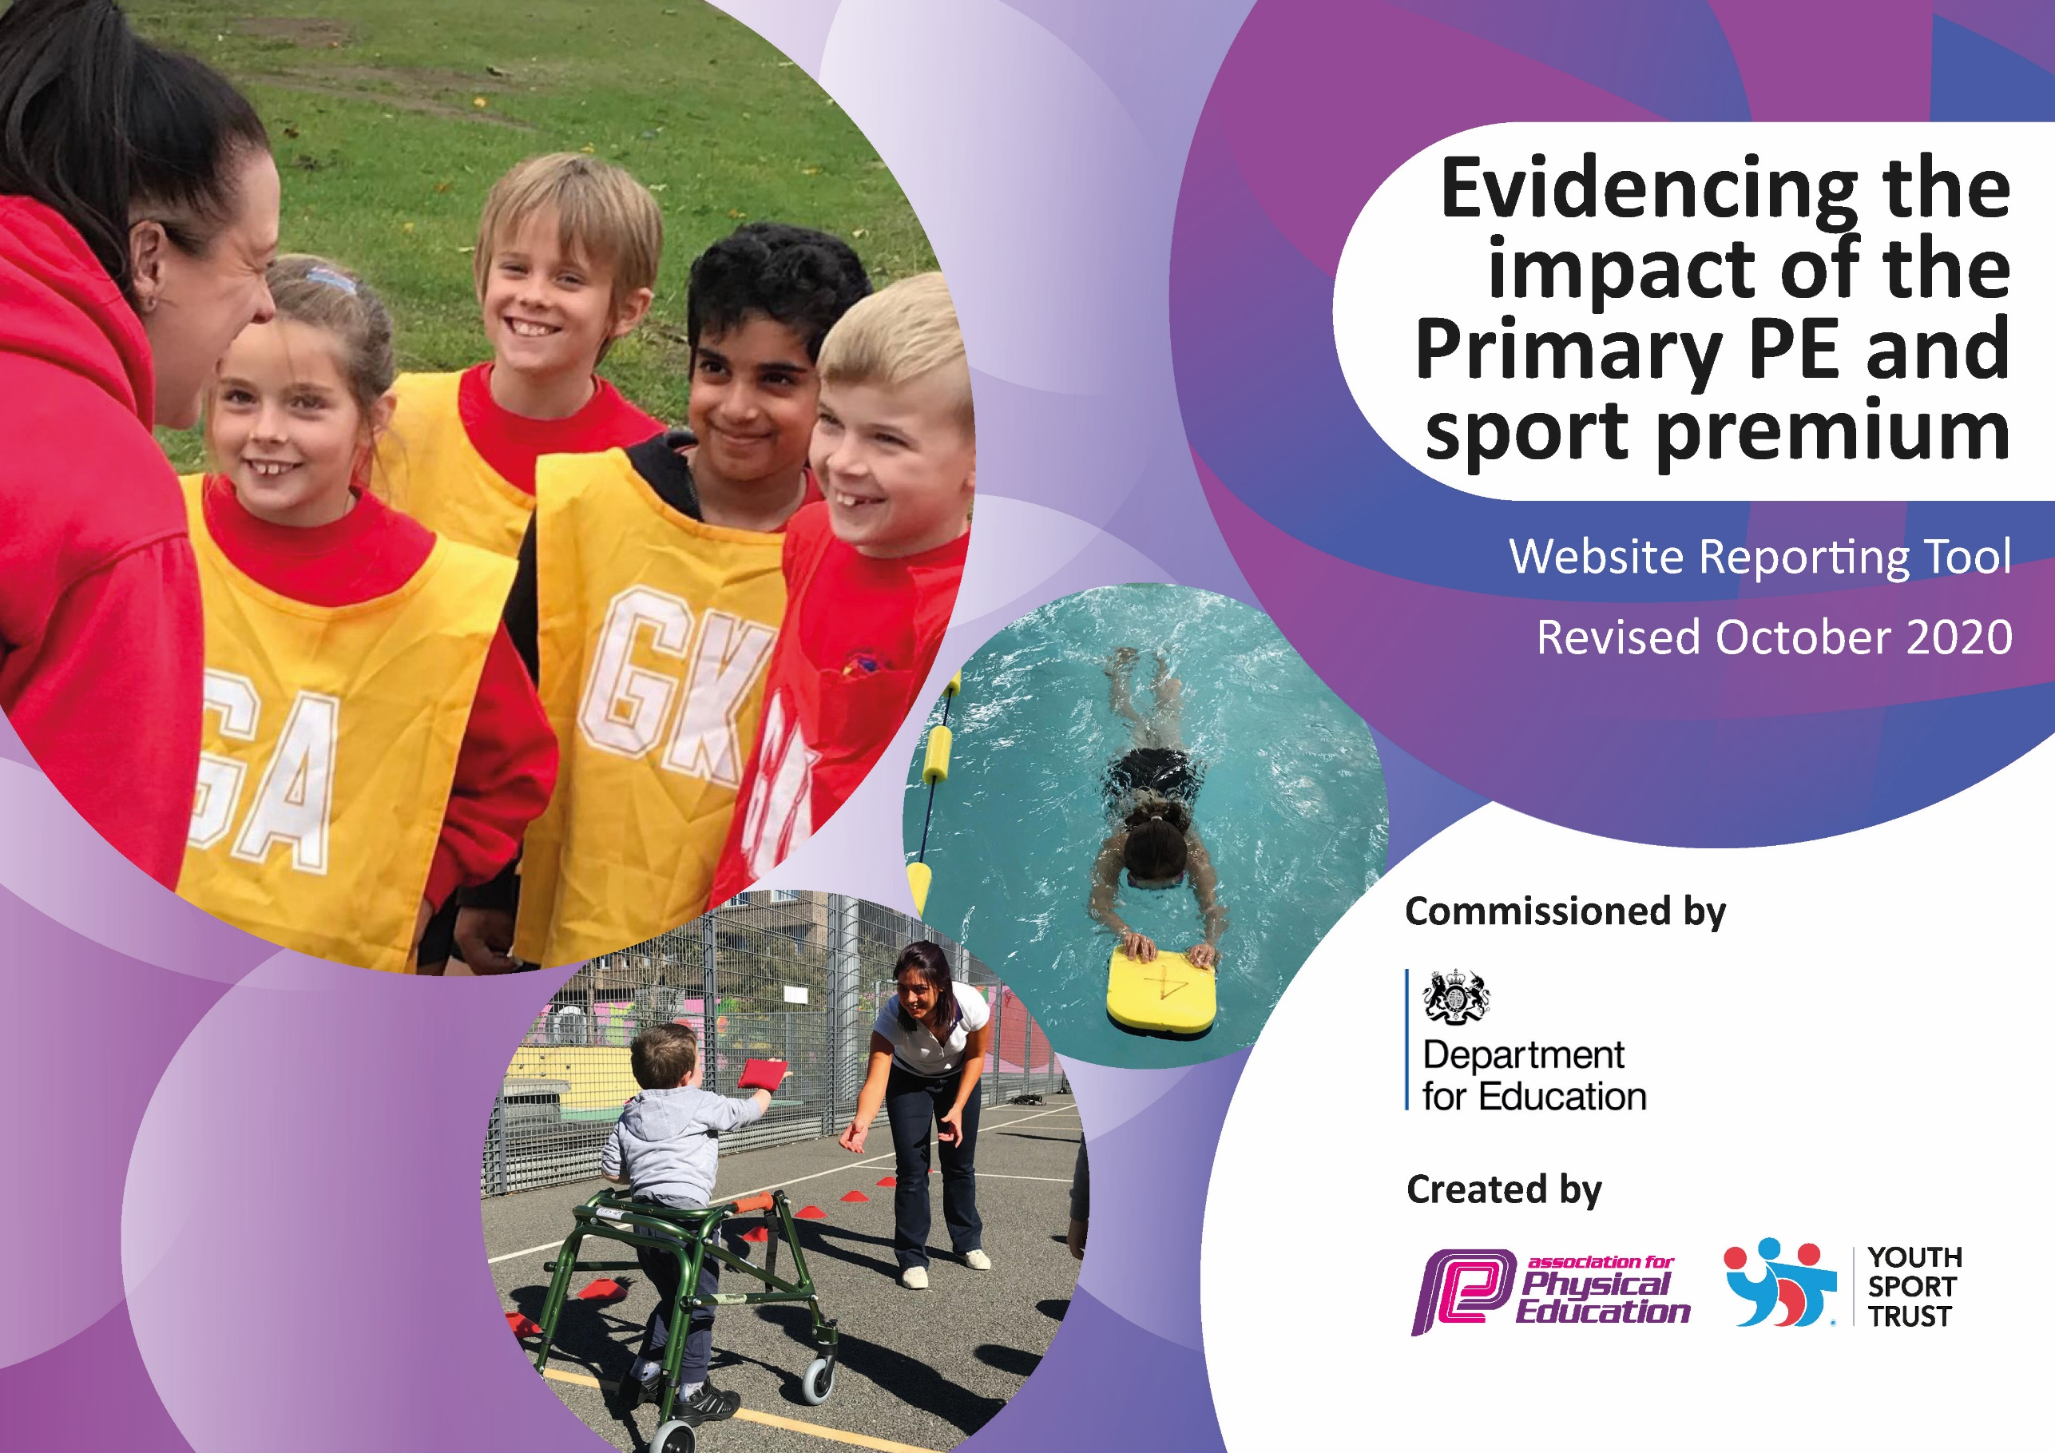
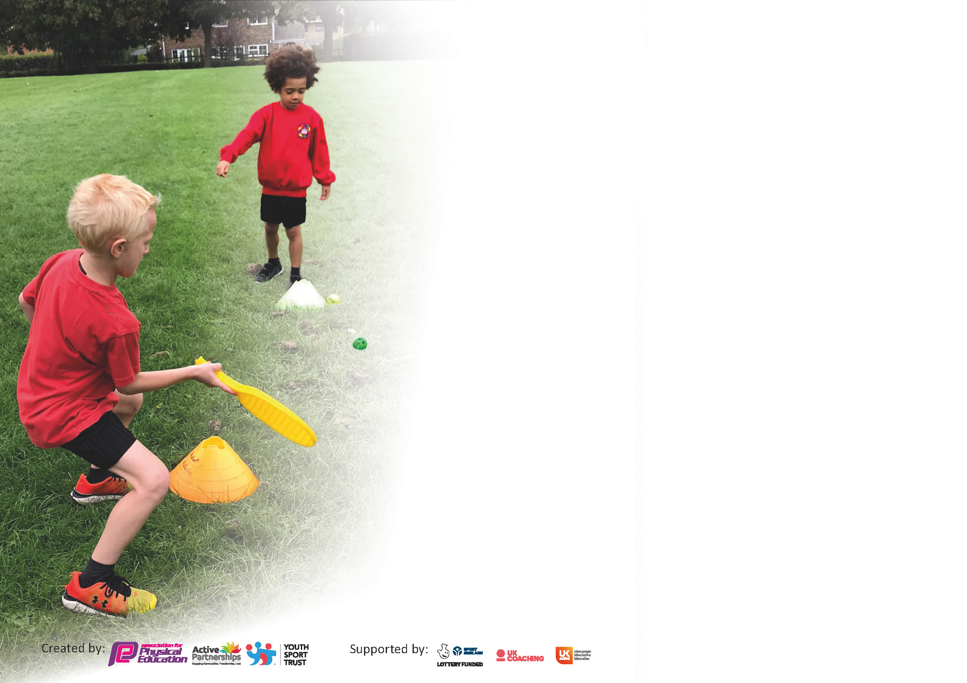

It is important that your grant is used effectively and based on school need. The Education Inspection Framework (Ofsted 2019 p64) makes clear there will be a focus on ‘whether leaders and those responsible for governors all understand their respective roles and perform these in a way that enhances the effectiveness of the school’.

Under the Quality of Education criteria (p41) inspectors consider the extent to which schools can articulate their curriculum (INTENT), construct their curriculum (IMPLEMENTATION) and demonstrate the outcomes which result (IMPACT).

To assist schools with common transferable language this template has been developed to utilise the same three headings which should make your plans easily transferable between working documents.

Schools must use the funding to make additional and sustainable improvements to the quality of Physical Education, School Sport and Physical Activity (PESSPA) they offer. This means that you should use
the Primary PE and sport premium to:

- Develop or add to the PESSPA activities that your school already offer
- Build capacity and capability within the school to ensure that improvements made now will benefit pupils joining the school in future years

Please visit gov.uk for the revised DfE guidance including the 5 key indicators across which schools should demonstrate an improvement. This document will help you to review your
provision and to report your spend. DfE encourages schools to use this template as an effective way of meeting the reporting requirements of the Primary PE and sport premium.

We recommend you start by reflecting on the impact of current provision and reviewing the previous spend.

Schools are required to publish details of how they spend this funding as well as on the impact it has on pupils’ PE and sport participation and attainment by the end of the summer term or by 31st July 2021 at the latest.

** In the case of any under-spend from 2019/20 which has been carried over this must be used and published by 31st March 2021.

We recommend regularly updating the table and publishing it on your website throughout the year. This evidences your ongoing self-evaluation of how you are using the funding to secure maximum, sustainable impact. Final copy must
be posted on your website by the end of the academic year and no later than the 31st July 2021. To see an example of how to complete the table please click HERE.
Created by: Supported by:

Please note: Although there has been considerable disruption in 2020 it is important that you publish details on your website of how you spend the funding - this is a legal requirement.
Support for review and reflection - considering the 5 key indicators from DfE, what development needs are a priority for your setting and your pupils now and why? Use the space below to reflect on previous spend and key achievements and areas for development.

N.B. In this section you should refer to any adjustments you might have made due to Covid-19 and how these will influence further improvement.
Key achievements to date until July 2020: | Areas for further improvement and baseline evidence of need:
- Continued high levels of participation in competitive sports and sporting experiences through the local sport partner ships such as SST – Shepway Sports Trust and Folkestone Sports Centre (Squash & Water Polo & Swimming Gala).  - Virtual competitions run successfully during lockdown.  - Opportunities offered to all pupils to participate in sports and physical activities.  - Structured activities improved for KS1 during play and lunch times.  - We have continued to offer a range of lunch time clubs to offer sporting experiences to those who are not able to attend after school clubs run by Shepway Sports Trust, PE coordinator (CK), Play leaders and Active Health Leader (SG) and Active Health Crew.  - We have increased the number and variety of after school sports clubs available including Sea Sports in Term 6.  - Mr Rudkin has been employed as the swimming coach and he is making significant progress in developing confidence and ability with children in Years R to 4 in their swimming sessions.  - We have been able to offer additional after school swimming clubs for Years 1 to 6 to provide opportunities to swimming progression.  - The end of year celebration of sports event ‘Whirl Around the World’ continued to offer a variety of alternative sports and inclusive sports to all children and their parents; promote the School Games Sporting Values of Determination, Honesty, Respect, Passion, Teamwork, and Self Belief. Inspiration was provided by Storm Porter (National Rhythmic Gymnast) and The Knuckle Ball Twins (Ball skills Display).  - Continued CPD provided for teachers in Yoga, Gymnastics, Indoor Athletics, Outdoor Athletics, Handball and Netball. | - New PE Coordinator (ED) to attend CPD and virtual training meetings to gain a deeper understanding of the subject.  - Development of whole school approach to PESSPA to encourage active lifestyles.  - Re-evaluate the curriculum map for the school to ensure that all areas of the curriculum are being covered.  - Promote healthy lifestyle choices through Change 4 Life, Daily Mile, Walking Bus, Scoot to School.  - Use Dojo/school newsletter to inform and engage parents and promote the benefits of exercise for the physical and emotional health.  - Develop experiences further through wider partnerships with local sports providers; E.g. Hythe Tennis Club, Folkestone RC Junior Athletics, Tom Middleton (Inclusive sports- sit down volleyball) and Sea Point Canoe Centre (https://www.seapointcanoecentre.co.uk/). (When Covid restrictions allow)  - Improve variety of after school clubs; E.g. Water sports through Sea Point Canoe Centre; Trampoline and Badminton at Folkestone Sports Centre; Wall climbing and skate boarding through SST and F51 centre when opened. (When Covid restrictions allow)  - Continue to promote pupil voice through student council.  - Provide refresher training/ CPD for teacher to resume teaching swimming in the school pool.  - Use staff Audit to provide further CPD opportunities in areas such as Mindfulness, Cross Curricular Focus or any other area requested by staff.  - Increase participation in the virtual competitions and My Personal best competitions.  - Play leaders and Active Health Crew run a range of activities to help promote active lifestyles – target less active, vulnerable and SEND pupils.  - PE Coordinator to undertake observations (when Covid restrictions allow) to provide support and develop action plan where needed.  - Work with SMT and year 5 and 6 teachers to improve PESSPA provision for UKS2

Did you carry forward an underspend from 2019-20 academic year into the current academic year?
YES

If YES you must complete the following section

If any funding from the academic year 2019/20 has been carried over you MUST complete the following section. Any carried over funding MUST be spent by 31 March 2021.
Academic Year: September 2020 to March 2021 | Total fund carried over: £519.80 | Date Updated: 05/03/21
What Key indicator(s) are you going to focus on? Key indicator 4: Broader experience of a range of sports and activities offered to all pupils. Key indicator 5: Increased participation in competitive sport. |  |  |  | Total Carry Over Funding:
 |  |  |  | £519.80
Intent | Implementation |  | Impact
Your school focus should be clear how you want to impact on your pupils.  To introduce a new fun and inclusive sport to the school with the intention of improving children’s social, mental and physical skills as well as increasing participation in competitive sport by running inter/intra/virtual school competitions. | Make sure your actions to achieve are linked to your intentions:  Purchase equipment and TT Kids package with online training and resources. | Carry over funding allocated: £519.80  TT Kids starter pack 132.99  Table tennis tables x2 £719.99  Table tennis equipment  £59.39 | Evidence of impact: How can you measure the impact on your pupils; you may have focussed on the difference that PE, SS & PA have made to pupils re-engagement with school. What has changed?  High level of engagement in table tennis during PE lessons, lunchtime/playtime sessions and after school clubs. The Year 5 table tennis club won the national TT kids competition. | Sustainability and suggested next steps and how does this link with the key indicators on which you are focussing this academic year?  Continue to offer a wide range of opportunities for children throughout the school to engage and participate in a variety of table tennis activities.  Ensure to replace any damaged equipment.

Meeting national curriculum requirements for swimming and water safety.

N.B Complete this section to your best ability. For example you might have practised safe self-rescue techniques on dry land.
What percentage of your current Year 6 cohort swim competently, confidently and proficiently over a distance of at least 25 metres?  N.B. Even though your pupils may swim in another year please report on their attainment on leaving primary school at the end of the summer term 2021. | %
What percentage of your current Year 6 cohort use a range of strokes effectively [for example, front crawl, backstroke and breaststroke]? | %
What percentage of your current Year 6 cohort perform safe self-rescue in different water-based situations? | %
Schools can choose to use the Primary PE and sport premium to provide additional provision for swimming but this must be for activity over and above the national curriculum requirements. Have you used it in this way? | No

Action Plan and Budget Tracking
Capture your intended annual spend against the 5 key indicators. Clarify the success criteria and evidence of impact that you intend to measure to evaluate for pupils today and for the future.

Academic Year: 2020/21 | Total fund allocated: £19580 | Date Updated:31/07/21
Key indicator 1: The engagement of all pupils in regular physical activity – Chief Medical Officers guidelines recommend that primary school pupils undertake at least 30 minutes of physical activity a day in school |  |  |  | Percentage of total allocation:
 |  |  |  | %
Intent | Implementation |  | Impact
Your school focus should be clear what you want the pupils to know and be able to do and about what they need to learn and to consolidate through practice: | Make sure your actions to achieve are linked to your intentions: | Funding allocated: | Evidence of impact: what do pupils now know and what can they now do? What has changed?: | Sustainability and suggested next steps:
To improve children’s range of experience of PE, Sport and Physical Activity to improve:  - Wellbeing  - Enjoyment  - Involvement  - Fitness  - Knowledge of PESSPA  - Inclusion  Continue to provide opportunities for all pupils to compete regardless of ability; E.g. intra-sports competitions (lead and run by SGC, FSC).  Continue to provide a range of lunch time and after school clubs run by Shepway Sports Trust or other Sports coaches  Teaching assistants/Teachers to provide a variety of after school and lunchtime clubs. (Not during terms 3 and 4 due to covid)  Children to run clubs/lunchtime activities to encourage uptake and appreciation of PESSPA.  Find out what activities pupils would like to try.  Replace equipment when needed. | Designated day for PE Coordinator to organise, review and improve school provisions. Also providing lunch time activities and after school.  Due to Covid restrictions all competitions are currently Virtual and completed in year group bubbles. Organised by SST  Shepway Sports Trust also provide after school and lunch time clubs.  Term 1+2 - Hockey Club Year 5  Dance club and Golf Club planned for Terms 5 and 6 (as soon as Covid restrictions allow)  Basketball club Terms 1+2  Ball skills Term 1+2  Girls football club Term 2  Table Tennis/Football/Yoga clubs planned for Terms 5/6  Sports Crew Y5/6 training provided for staff and children (Free). Virtual training planned for Term 2 Supported by PE Coordinator and SG  Pupil survey carried out through Student Council.  Davies Sport – New footballs, Basketball net, skipping ropes, beanbags. | PE Coordinator (Oncosts £9900).  Currently free.  Shepway Sports Trust (£32 per session)  Run by TA (£15)  Run by TA (£15)  Free  Free  Yoga Run by TA (£15)  Free  Free  £350 | PE Coordinator has:  promoted and organised participation in. a variety of virtual competitions through Shepway Sports for the whole school to take part in. Many children received medals for their efforts.  Provided virtual training for 16 year 5 and 6 children to be Sports Crew (organising lunchtime competitions for their peers to take part in)  Provided a table tennis after school club where Year 5 participants won a national competition.  Successfully re introduced and implemented the daily mile which saw enthusiastic participation from all students.  Organised CPD for staff in dance and Hockey, very positive feedback from staff regarding it’s impact.  Children took part in Speedstacks, Basketball, Football, Cross Country, Personal best challenges and Multi-skills competition organised by Shepway Sports. There was a high level of engagement and Medals won for the school in every event.  Children from across the school were given the opportunity to participate in a variety of clubs. This was more limited than usual due to Covid restrictions but every year group was catered for. Football, Girls Football, Hockey, Table Tennis, Dance, Yoga clubs were offered.  TA’s and Teachers are committed and enthusiastic about delivering high quality sports activities to the children  16 year 5 and 6 children underwent Virtual training to become Sports Crew enabling them to organise lunchtime competitions for their peers to take part in. The children were fully engaged and enthusiastic.  Before we made changes to the curriculum the children were consulted via a survey to find out which sports they would prefer to take part in. Their responses were then taken into consideration.  Football and Basketball are very popular at Christ Church. Ensuring we have the relevant equipment available for the children to use during PE lessons, at after school clubs or at playtimes and lunchtime encourages a high level of enthusiasm and participation. Skipping ropes and beanbags were needed for Sports day. | Continue to organise intra/inter competitions for the whole school.  Choose 8 new members of year 5 for Sports Crew training, to join the existing members.  Continue to promote Table Tennis as a sport through clubs and lunchtime activities.  Continue to promote and encourage whole school participation in the daily mile.  Regular opportunities for staff to take part in relevant CPD  Introduce My Personal Best initiative as a whole school approach to PE lessons.  We will continue to take part in any intra sports competitions that are organised.  To work on building a greater selection of extra-curricular opportunities for children across the school.  Continue to encourage a high level of participation here.  Continue to work with the remaining members of Sports Crew and choose 8 new members of year 5 for Sports Crew training, to join the existing members.  Continue to involve the children in decision making process and provide frequent opportunities for children to feedback on their PESSPA experiences.  Continue to provide adequate equipment for children to use.  Make sure there is sufficient equipment for the sports to be taught in the re-modelled curriculum.  Regularly monitor condition and levels of equipment in the PE cupboard. Consider the possibility of ordering new football goals
Key indicator 2: The profile of PESSPA being raised across the school as a tool for whole school improvement |  |  |  | Percentage of total allocation:
 |  |  |  | %
Intent | Implementation |  | Impact
School focus should be clear what you want the pupils to know and be able to do and about what they need to learn and to consolidate through practice: | Make sure your actions to achieve are linked to your intentions: | Funding allocated: | Evidence of impact: what do pupils now know and what can they now do? What has changed?: | Sustainability and suggested next steps:
Children, parents and staff to understand the importance of PEPPSA and the benefits physically, emotionally and mentally.  To promote healthy lifestyles.  Inform staff and parents of resources and activities.  Increase participation in Physical Activity outside of PE lessons. Use PA to improve children’s fitness, concentration, coordination and engage in competitive activity.  Celebration of Sports day, Planned for Term 6 depending on Covid restrictions. | Use assemblies to share and promote events and inspire healthy lifestyles.  Use Class dojo to share online resources with parents.  School staff to use C4L resources and recipes to encourage healthy lifestyles.  Change 4 Life Cookery Club planned from Term 5 to help promote healthy lifestyles.  Use school website sports page and Class Dojo school page to share information with pupils and parents  Display sports calendar and other information on staff notice board.  Purchase of two mobile Activall units for use at the beginning of the day, at break times and lunch times to involve/engage children in PA outside PE lessons.  Daily mile to be completed daily by all year groups. Daily mile journey around the world with daily mile passports.  Whirl Around the World to encourage  enjoyment in a variety of sports and  physical activities. Opening and closing  ceremonies with Samba Drums. Medals for Sporting Values and House Haka’s.  School Staff, Shepway Sports Trust Coaches, Archery and Golf/Table tennis (Mr Denham). | . Free  Free  Free  £6500  Free  This will now come out of next year’s PE budget. | Class Dojo was an extremely effective way of sharing sports activities, virtual competitions, lifestyle tips and exercise ideas with parents and children during lockdown. A large number of families took part in a variety of activities and shared photos of them completing them  Cookery club was not able to take place due to Covid, however our wrap around care afterschool club works hard to promote healthy eating and encourages a variety of activities for the children which include: roller skating, cycling, scootering, table tennis and trampolining.  Pupils and parents were provided with information, ideas and resources to support healthy living choices, even more so during lockdown. Also use to publish events.  The children have participated enthusiastically with this portable equipment which improves co-ordination, speed and accuracy and encourages competition and improving personal best scores.  It was not possible to organise this event this academic year due to covid restrictions. We have rescheduled the event for 18 and 19th October. | Plan a number of Inspiring assemblies for the next academic year. To include an assembly from an International athlete.  Plan to reinstate C4L cookery club next academic year. Continue the great attitudes promoted at the wraparound care afterschool club.  Continue to inform and engage families using Class Dojo.  Organise a timetable for lunchtime playtime to maximise the opportunities for using this equipment. Consider creating a whole school leaderboard.

Key indicator 3: Increased confidence, knowledge and skills of all staff in teaching PE and sport |  |  |  | Percentage of total allocation:
 |  |  |  | %
Intent | Implementation |  | Impact
Your school focus should be clear | Make sure your actions to | Funding | Evidence of impact: what do | Sustainability and suggested
what you want the pupils to know | achieve are linked to your | allocated: | pupils now know and what | next steps:
and be able to do and about | intentions: |  | can they now do? What has
what they need to learn and to |  |  | changed?:
consolidate through practice:
Encourage teachers (NQT Focus) to develop their CPD in PE and Sports by taking up the coaching support available with SST or other providers.  Provide teachers with resources and CPD to enable them to teach high quality lessons and clubs confidently and competently.  Keep up to date with PESSPA expectations and share with staff. | Staff Questionnaire/Survey Survey Monkey  Areas of CPD have been identified (Dance, Gymnastics, Athletics, Cricket, Hockey and Pop Lacrosse)  Training will be provided to give teachers the skills and confidence to teach quality lessons.  - CPD Provided by SST for KJ Term 1 (Dance)  - CPD Provided by SST for CP and RP Term 2 (Dance)  - CPD Provided by SST for CP and AH Term 5 Hockey  PE Hub Membership  AfPE, YST and Gov. Websites  Membership for Table Tennis England  TT kids schools package  Youth Sports Trust membership  Email staff with any updates and invite feedback. | Free  Term 1 - 3 x 1hour  Term 2 - 6 x 1hour  Term 2 - 5 x 40mins (charged at 1hour)  3+6+5= 14 hours x £42= £588  £350  Free  Free  £132.95  £210 | CPD from experienced sports staff has meant teachers now feel more confident to teach lessons and run clubs.  PE Hub provides easy to follow resources with videos to support teaching of PE.  YST provided a variety of useful resources and CPD to support teaching and providing PA during play and lunch times.  Staff are well informed and know where to come for help and advice. If the PE coordinator cannot assist then she ensures to find a way of finding answers. | Review and repeat survey annually.  We plan to run several whole school CPD sessions ahead of the term we will be teaching specific sports.  Continue to subscribe to PE hub as a planning tool. Work on incorporating the MY PB initiative.  Introduce to the My PB initiative which fits really well with our school vision. Staff to complete a virtual My PB workshop in September.  PE coordinator to keep up to date with PESSPA expectations pursue any professional development opportunities and share with staff.
Key indicator 4: Broader experience of a range of sports and activities offered to all pupils |  |  |  | Percentage of total allocation:
 |  |  |  | %
Intent | Implementation |  | Impact
Your school focus should be clear | Make sure your actions to | Funding | Evidence of impact: what do | Sustainability and suggested
what you want the pupils to know | achieve are linked to your | allocated: | pupils now know and what | next steps:
and be able to do and about | intentions: |  | can they now do? What has
what they need to learn and to |  |  | changed?:
consolidate through practice:
Work with local agencies to provide a wider range of activities that will inspire our children to take up sports. Choose activities that have low running costs.  Find out what the pupils would like to do. | Hockey After School Club Yr5  Basketball After School Club Yr6  Football Skills After School Club Year 1  Further clubs to be offered for terms 5+6 (Dance, Table tennis)  Pupil Survey | Shepway Sports Trust (£32 per session)  Run by TA (£15 per session)  Run by TA (£15 per session) | With the clubs that went ahead, children from most year groups were able to enjoy and experience sports and activities they would not normally do. We were limited because we could not invite in outside agencies apart from SST and we had to operate after school clubs in Year group bubbles. No clubs could be offered in term 3.  Children felt empowered when asked for their opinions. | Work on building up the number and variety of clubs offered next academic year both in school and out. Ensure that every child has the opportunity to take part in an activity.  Repeat survey regularly

Key indicator 5: Increased participation in competitive sport |  |  |  | Percentage of total allocation:
 |  |  |  | %
Intent | Implementation |  | Impact
Your school focus should be clear | Make sure your actions to | Funding | Evidence of impact: what do | Sustainability and suggested
what you want the pupils to know | achieve are linked to your | allocated: | pupils now know and what | next steps:
and be able to do and about | intentions: |  | can they now do? What has
what they need to learn and to |  |  | changed?:
consolidate through practice:
To book A, B and C team onto Shepway Sports Trust events, so all children have the opportunity to participate in sport events.  Provide Transport | Virtual Interschool competitions. Due to Covid restrictions all competitions are currently Virtual within year group bubbles.  Book Cross Keys, R&J Coaches or  Folkestone sports centre Mini bus for transport to sports events. | Free  £0 | No face to face competitions took place this year due to Covid. However, the children took part the virtual competitions competitively and enthusiastically and medals were won in all competitions. The Year 5 table tennis club achieved National Champions in the Table Tennis competition.  No transport was booked this academic year. | Ensure that the school is well represented at face to face events and all children are given the opportunity to take part.  Transport to be booked in advance for any sports events outside of school.

Signed off by
Head Teacher:
Date:
Subject Leader: | Esther Denham
Date:
Governor:
Date:

