Striving to be the best version of ourselves every day.

Inspired by God’s love, we humbly strive to be
the best version of ourselves every day, in every way.

We cherish the dignity of each precious person:
thankfulness, friendship, forgiveness and hope
are at the heart of our inclusive community.

Child Protection Policy

Christ Church CEP Academy

How we keep you safe at school
September 2023

based on Keeping Children Safe in Education 2023

Who can help keep you safe

Every adult in the school has had training to keep you safe.

These people play a special part in making sure everyone is well looked after.
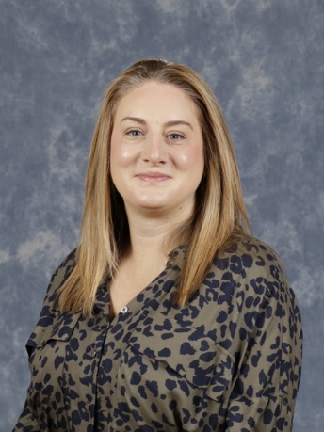
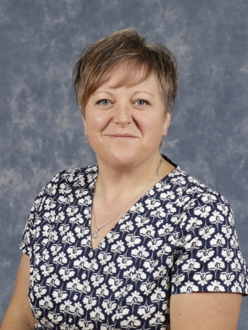

Miss Perkins Mr Flack Mrs Atkins

Mrs Sue Dinsdale is one of our school governors. She makes sure that we are doing a good job.

All the adults in our school have read this policy. We check it every year to make sure that it is up-to-date.

Why am I reading this?

At Christ Church CEP Academy we believe that keeping you safe is our most important job. Everybody is responsible for making sure that our school is a safe place to be including: teachers, volunteers, governors, parents and you!

We want you to feel safe and respected. We want you to feel like you can talk to us about your worries.

As well as keeping you safe from harm we will help you to learn how to keep yourself safe.

How do the adults keep me safe?

All of the adults in our school must do these things:

- Provide a safe environment in which you can learn.
- Be prepared to help you quickly.
- Understand some of the dangers which may harm you and how to spot the signs that someone is harming you.
- Work with Mr Flack and Miss Perkins and know how to get help if they aren’t there.
- Have regular training.
- Know what to do if you tell them that you are worried or upset.
- Make sure that the right adults know about your worries so that they can help you.
- Help you parents and trusted adults to know how to keep you safe including online safety.

What happens if adults aren’t doing these things?

If you are unhappy about a member of staff then you have the right to make a complaint. You can talk to the Headteacher or ask your parents to help you by following the school complaint procedure.

What do the school do with my private information?

Any information that we keep about you and your family is stored online using CPOMS. It is safe and secure so that no one who doesn’t need to know can find out your details.

We will only share your information with professionals who can help you. You can talk to the adults at school if there is any information which you do not want to be shared although sometimes we must share this information to keep you safe.

When you change schools your new school we get a copy of all this information.

What should I do if someone at school hurts or upsets me?

It is very important that you tell a trusted adult if someone at school hurts or upsets you. Here are some of the things that you can do:

- Tell a parent of family member
- Tell an adult at school
- Phone Child Line (0800 1111) or go online www.childline.org.uk

How do I know if an adult in school is safe?

All adults in our school have had special checks to ensure that they are safe and trustworthy.

How can I keep myself safe?

In your Jigsaw lessons your teacher will make sure that you understand how to keep yourself safe from:
- Risky behaviour online
- Inappropriate touch
- Unhealthy relationships including online relationships
- Risky behaviour in the community and online
- Gangs and violence
- Prejudice
- Physical harm

Remember that you can talk to Child Line

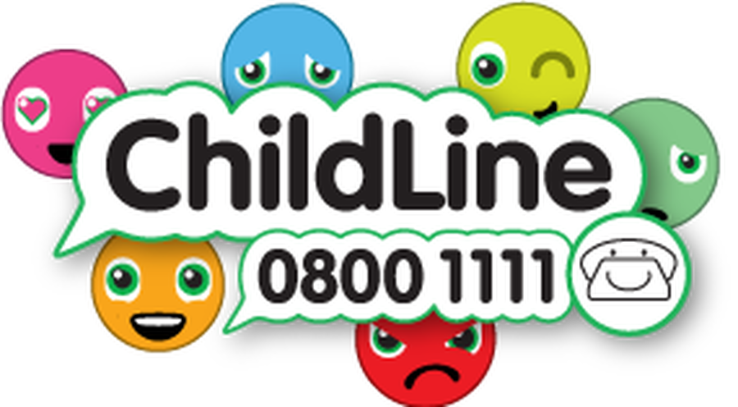

We write down what was said or what happened that worried us.
If a child has told us about a worry then we reassure them and help them to feel calm.
The adult who is worried talks to Miss Perkins, Mr Flack or Mrs Atkins
We then talk to some experts to find out how best to help the child that we are worried about.

Sometimes the experts decide to come in a talk to the child.
If we are still worried then we can talk to the NSPCC
We also take advice
We record what we have done
We keep checking to make sure that the worries have gone away.

If we think that the child needs more help than we decide how we can help them
Think about why we are worried
Did a child tell us something?
Did we see something that made us feel worried?
What we do when we are worried about a child

